* 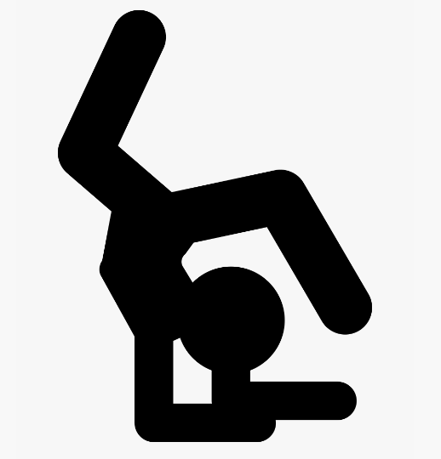

**Albury:** 1/1014 Nowra St

North Albury, NSW 2640 Ph. 60 41 1127

**e** [flyawaygymnastics@hotmail.com](mailto:flyawaygymnastics@hotmail.com) **w** [www.flyawaygymnastics.com.au](http://www.flyawaygymnastics.com.au)

* Arrive 5 minutes before the class conclusion to collect your gymnast promptly at the class finish time.
* Gymnasts will be waiting on markers in the designated waiting area that will be supervised by staff.
* Coaches will assist gymnasts outside once their parent has been spotted.
* Leave the premises immediately after training has concluded.

GET OUT.

* Arrive at the gym NO MORE than 10 minutes before your class start time.
* Front Door Access will be kept locked at all times. Parents are not allowed in the building.
* Wait outside on grass area until gymnasts are welcomed in by their coach 5 minutes prior class start.
* Do not congregate at the entry and always keep a minimum 1.5-meter distance between yourself and others.
* Bring minimal belongings: arrive dressed and ready to train, there will be no access to changing rooms.
* Bring your own drink bottle, filled with water, and clearly labelled. No sharing of drink bottles is permitted.

TRAIN,

You must not enter Flyaway Gymnastics if you (self assess):

* Feel unwell, have any flu like symptoms or have a temperature above 38°C
* Have been in contact with a known or suspected case of COVID-19 in the last 14 days or travelled to a Government declared hot spot or red zone.
* Gymnasts who have had symptoms of any illness may return to our facilities only when they have had 72 hours of no symptoms.

GET IN,

* During KinderGym classes only one parent or carer per child will be allowed. Please contact the office for information on additional siblings.
* Utilise sanitiser on arrival, when directed by a coach, after using the bathroom and when leaving the gym.
* Cover mouth and nose with a tissue or your elbow (not your hands) when you cough or sneeze and place tissues directly in bins.
* Avoid touching eyes, nose or mouth.
* Avoid contact with coach or other athletes (including hi-fives and hugs)
* Please take physical distancing seriously and abide by club signage and your coach’s instructions.
* Where signage is not posted, please adhere to the minimum 1.5m rule.
* Athletes will not be allowed to eat on premises.